PERIMETER
Pearson Edexcel - Monday 12 November 2018 - Paper 3 (Calculator) Higher Tier
1.
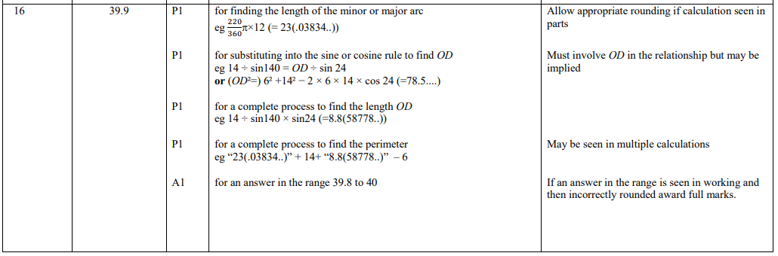
Pearson Edexcel - Specimen Papers Set 1 - Paper 2 (Calculator) Higher Tier
2.
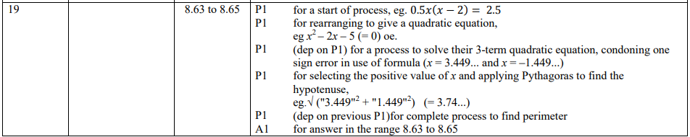
3.
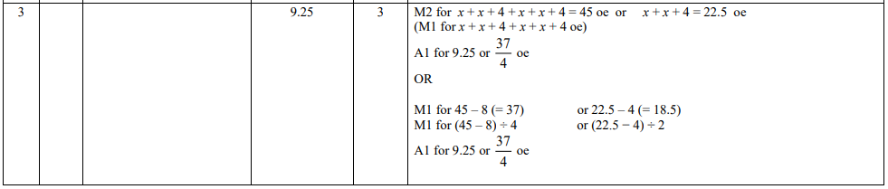
Pearson Edexcel - Thursday 9 June 2016 - Paper 2 (Calculator) Higher Tier
4.
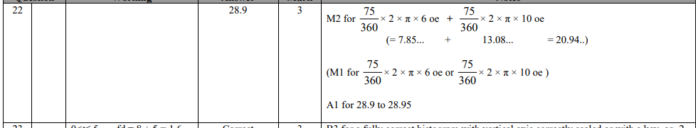
Pearson Edexcel - Thursday 4 June 2015 - Paper 1 (Non-Calculator) Higher Tier
5.
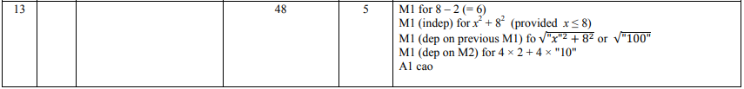
Pearson Edexcel - Friday 13 June 2014 - Paper 2 (Calculator) Higher Tier
6.
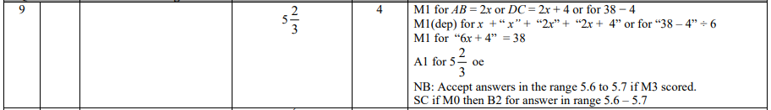
Pearson Edexcel - Wednesday 6 November 2013 - Paper 1 (Non-Calculator) Higher Tier
7.
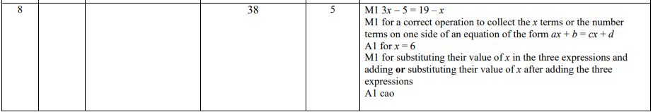
Pearson Edexcel - Tuesday 11 June 2013 - Paper 1 (Non-Calculator) Higher Tier
8.
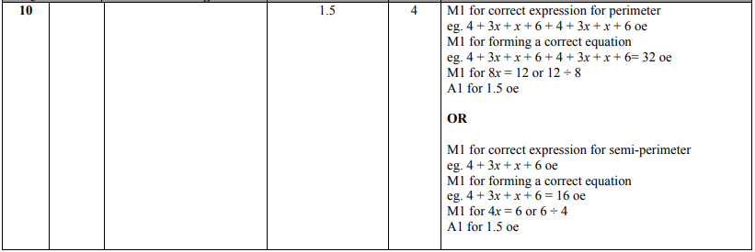
Pearson Edexcel - Monday 5 March 2012 - Paper 4 (Calculator) Higher Tier
9.
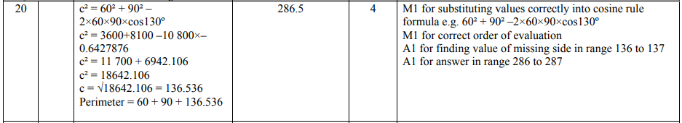
Pearson Edexcel - Tuesday 10 November 2009 - Paper 4 (Calculator) Higher Tier
10.
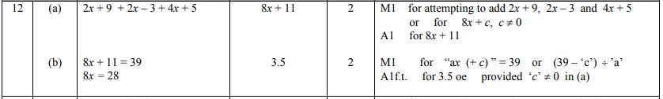
OCR GSCE – Monday 11 November 2019 – Paper 6 (Calculator) Higher Tier
11.
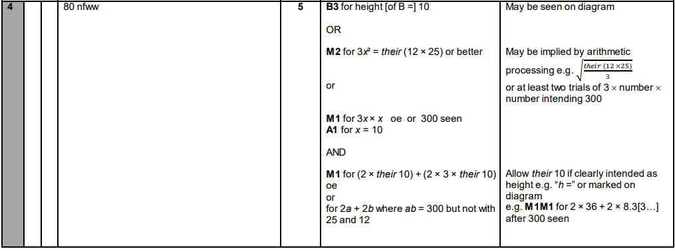
OCR GSCE – Tuesday 21 May 2019 – Paper 4 (Calculator) Higher Tier
12.
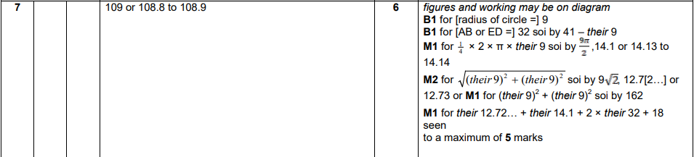
OCR GSCE – Thursday 25 May 2017 – Paper 4 (Calculator) Higher Tier
13.
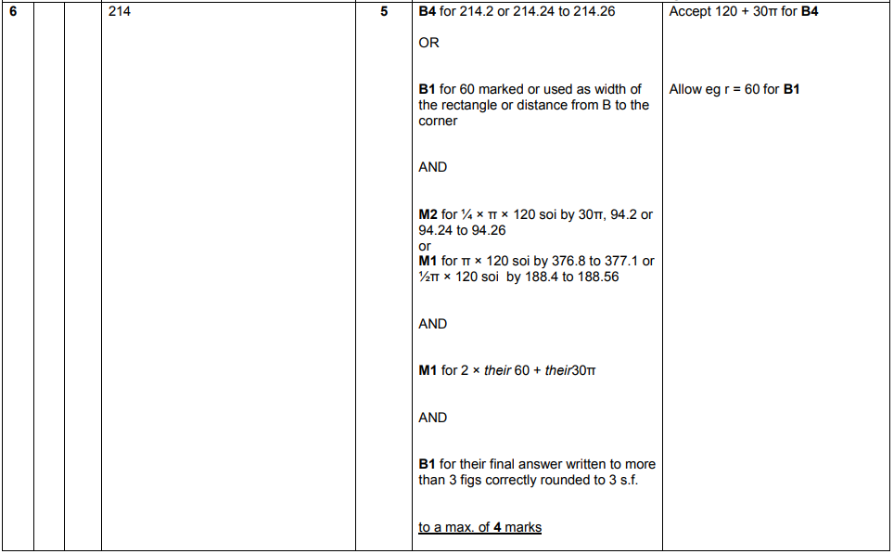
AQA GSCE – Thursday 8 June 2020 – Paper 3 (Calculator) Higher Tier
14.
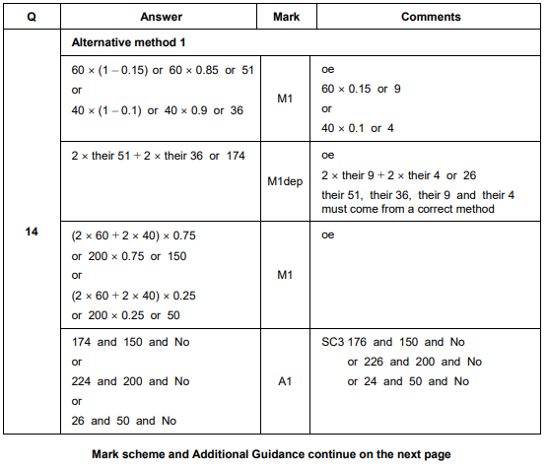
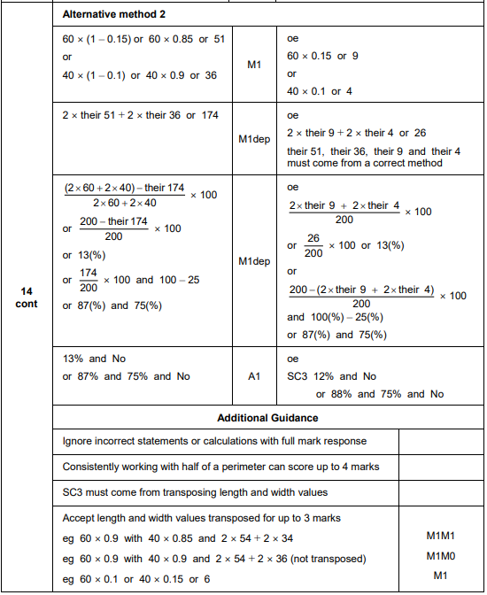
AQA GSCE – Monday 24 May 2018 – Paper 1 (Non - Calculator) Higher Tier
15.
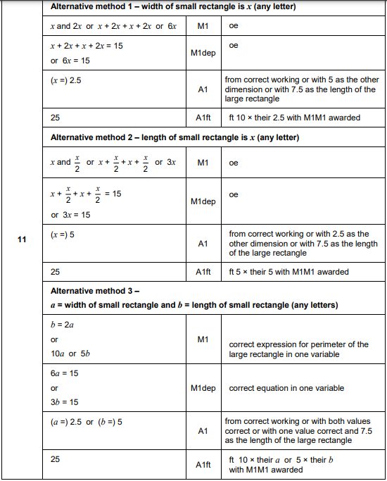
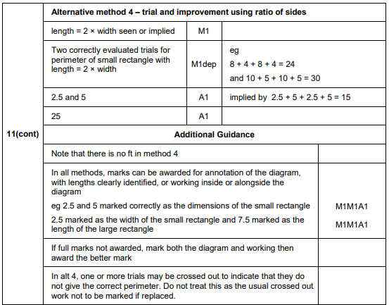
AQA GSCE – Thursday 7 June 2018 – Paper 2 (Calculator) Higher Tier
16.
